User Adoption Prediction

The goal of this project is to analyze the data on 12000 users that have signed up for the product in the last 2 years and identify which factors predict the future of user adoption. We define user adoption as a user who has logged into the product on 2 separate days in at least one 7-day period. There are 2 data files provided – one containing the user information and the other containing user login information

Steps

* Create Adopted user with window of 7 days with more than 3 logins
* Perform EDA
* Use Random forest and logistic regressor to predict and find important feature

EDA Insights

* Only 1602 users were adopted
* People with Guest Invite and Google Auth have higher conversion rate
* No other significant relation was observed

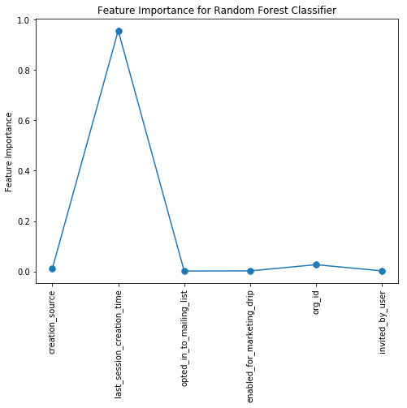

Modeling Insights

* Last_session_creation_time is the most relevant feature, though it doesn’t really make sense to consider this in the prediction model.
* Org_id (the organization id) is the next most relevant feature (which seems to agree with the EDA analysis)
* The model achieves an overall F1-score of 0.91